# GRAPHIC ERA DEEMED TO BE UNIVERSITY



SESSION 2022-23 WEBDEVELOPMENTLAB (PCS -693 )

Submitted To: Submitted By:

Mr. Pranav Moore

Department of CSE

and Information Technology

Rajvardhan

se

51

2015095

VIthSem

B.Tech(c.s.e)

# Design a form for Employee registration which includes all elements of form tags.

<!DOCTYPE html>

<html lang="en">

<head>

<meta charset="UTF-8">

<meta http-equiv="X-UA-Compatible" content="IE=edge">

<meta name="viewport" content="width=device-width, initial-scale=1.0">

<title>Employee Registration Form</title>

</head>

<style> body {

margin: 0px; padding: 10px; text-align: start;

}

input {

margin: 10px;

}

.abhi {

text-align: center;

}

.content

{margin-left: 33%;

}

</style>

<body>

<h1 class="abhi">Employee Registration Form</h1>

<div class="content">

<label for="name">Full Name:</label>

<input type="text">

<br>

<label for="name">Father's Name:</label>

<input type="text">

<br>

<label for="name">Mother's Name:</label>

<input type="text">

<br>

<label for="dob">DOB:</label>

<input type="date" name="dob" id="dob">

<br>

<label for="name">Email:</label>

<input type="text">

<br>

<label for="name">Contact Number:</label>

<input type="text">

<br>

<label for="name">Address:</label>

<input type="text">

<br>

<label for="gender">Gender:</label>

<input type="radio" name="gender"> Male

<input type="radio" name="gender"> Female

<input type="radio" name="gender"> Other

<br><br>

<label for="Department">Department:</label>

<select name="dep" id="dep">

<option value="accounts">Accounts</option>

<option value="admin">Administration</option>

<option value="it">IT</option>

<option value="management">Management</option>

</select>

<br><br>

<label for="image">Photo:</label>

<input type="file">

<br>

<input type="submit" value="Register">

<br><br><br><br>

</div>

</body>

</html>

**Output:-**

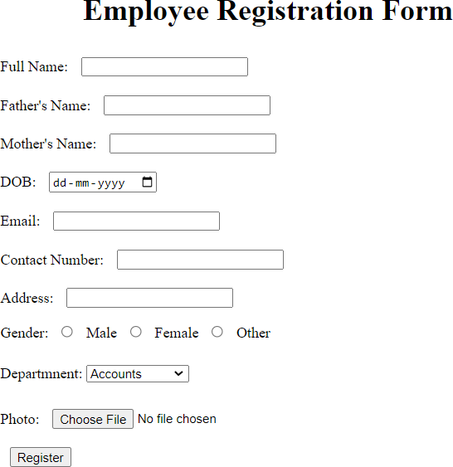

1. **Write a HTML code to generate a class timetable and add external CSS to customize the properties of the font, background etc. (color, bold and font size)**

<!DOCTYPEhtml>

<htmllang="en">

<head>

<metacharset="UTF-8">

<metahttp-equiv="X-UA-Compatible"content="IE=edge">

<metaname="viewport" content="width=device-width,initial-scale=1.0">

<title>TimeTable</title>

<linkrel="stylesheet"type="text/css"href="../CSS/abhi.css">

<scriptsrc="../Javascript/first.js"></script>

</head>

<body>

<h1 class="heading" style="text-align: center;">GRAPHIC ERA DEEMED TO BEUNIVERSITY</h1>

<h2 class="sub-heading" style="text-align: center;">ONLINE TIME TABLE OF

B.TECH.VIth SEMESTER “COMPUTER SCIENCE &ENGG.-H"</h2>

<h2 class="sub-heading-2" style="text-align: center;">ACADEMIC YEAR 2021-22</h2><pstyle="text- align:center;"><b>W.E.F:25thFebruary2022</b></p>

<div style="display: flex; justify-content: center; align-items: center;"><tablestyle="border:2px solid black;">

<thead>

<tr>

<th></th>

<th>9:00-9:55</th>

<th>9:55-10:50</th>

<th>11:10-12:05</th>

<th>12:05-1:00</th>

<th>1:00-1:55</th>

<th>1:55-2:50</th>

<th>3:10-4:05</th>

<th>4:05-5:00</th>

</tr>

</thead>

<tbody>

<tr>

<th>MON</th>

<td>TCS-602</td>

<td>TCS693</td>

<td>TCS-601</td>

<td>TCS-691/TCS-651/TCS-619</td>

<td>Lunch</td>

<td>XCS-601(PDP)</td>

<tdcolspan="2">CareerExcellenceClasses(CEC)</td>

</tr>

<tr>

<th>TUE</th>

<td>TCS-602</td>

<td>TCS693</td>

<td>TCS-601</td>

<td>TCS-691/TCS-651/TCS-619</td>

<td>Lunch</td>

<td>XCS-601(QAR)</td>

<td>TCS-604</td>

<td>TCS-604</td>

</tr>

<tr>

<th>WED</th>

<td>TCS-602</td>

<td>TCS693</td>

<td>TCS-601</td>

<td>TCS-691/TCS-651/TCS-619</td>

<td>Lunch</td>

<td>LIB</td>

<td>TCS-604</td>

<td>TCS-604(DiscussionClass)</td>

</tr>

<tr>

<th>THU</th>

<td>TCS-602</td>

<td>TCS693</td>

<td>TCS-601</td>

<td>TCS-691/TCS-651/TCS-619<br>(DiscussionClass)</td><td>Lunch</td>

<tdcolspan="3">SWAYAM/Training/Extra-CurricularActivities/LIB</td>

</tr>

<tr>

<th>FRI</th>

<tdcolspan="2">SoftwareEngineeringLab</td>

<tdcolspan="2">CompilerDesignLab</td>

<td>Lunch</td>

<td>LIB</td>

<tdcolspan="2">WebDevelopmentLab</td>

</tr>

</tbody>

</table>

</div>

<br><br><br><br>

</div>

</body>

</html>

***Output:-***

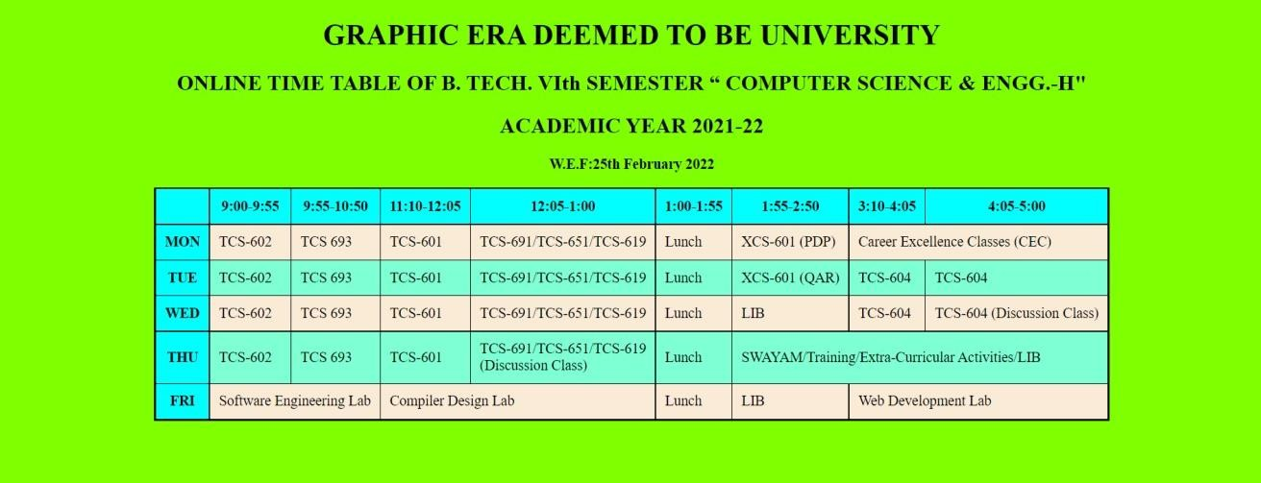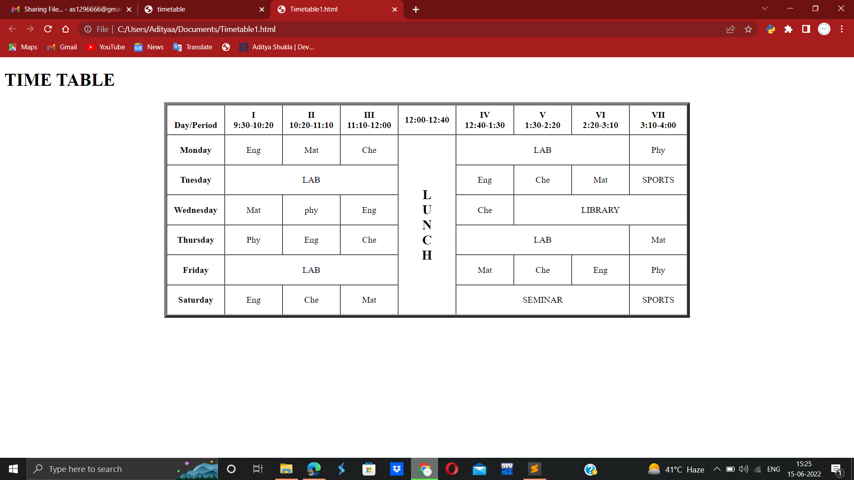

# Use frames such that page is divided into 3 frames 20% on left to show contents of pages, 60% in center to show body of page, remaining on right to show remarks.

(Frame.html)

<!DOCTYPE html>

<html>

<head>

<title>Frames</title>

</head>

<frameset cols="20%,80%" noresize="noresize" border="10">

<frame src="../HTML/frames/menu.html" name="menu_page">

<frame src="../HTML/frames/main.html" name="main_page">

</frameset>

</html>(main.html)

<!DOCTYPE html>

<html>

<body>

<h1>

<marquee Scrollamount=20>Select any planet </marquee>

</h1>

</body>

</html>(menu.html)

<!DOCTYPE html>

<html>

<head>

<style>body {

background-color: #fee7c1;

}

h1 {

color: #81130f; text-align: center;

font-family: sans-serif;font-size: 35px;

}

a:link { color: blue;

background-color: transparent;

}

a:visited { color: purple; background-color: transparent;

}

a:hover { color: red; background-color: transparent;

}

</style>

</head>

<body>

<h1> Selected Planets</h1>

<p style="font-size: 20px"> Read essential details about following planets.

<p>

<ul style="font-size: 20px">

<li><u> <a href="https://en.wikipedia.org/wiki/Venus"

target="main_page">Venus</a></u></li>

<br>

<li><u> <a href="https://en.wikipedia.org/wiki/Earth" target="main_page">Earth</a></u></li>

<br>

<li><u><a href="https://en.wikipedia.org/wiki/Jupiter"target="main_page">Jupiter</ a></u></li>

</ul>

</body>

</html>

Output:-

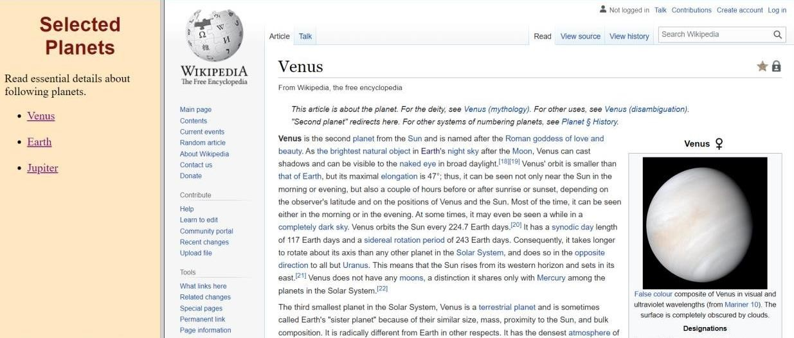

1. ***Write an HTML page that contains a selection box with a* list of 5 countries, when the user selects a country, its capital should be printed next to the list; Add CSS to customize the properties of the font of the capital (color, bold and font size).**

<html>

<head>

<title>capitals of countries</title>

<style>

p { color: red;

font-weight: bold; font-size: 50;

}

</style>

<script language="javascript"> function capital() {

var cunt = document.forms["frm1"].country.value; var capital = " Please select any country ";

if (cunt == "india") { capital = "NEW DELHI";

}

if (cunt == "china") { capital = "BEIJING";

}

if (cunt == "pakistan") { capital = "ISLAMABAD";

}

if (cunt == "bangladesh") { capital = "DHAKA";

}

if (cunt == "japan") { capital = "TOKYO";

}

if (cunt == "select") {

capital = "Please select any country";

}

document.getElementById("capt").innerHTML = capital;

}

</script>

</head>

<body>

<form name="frm1">

<br />

<center>

Select a Country :<select name="country" onchange="capital()">

<option value="select">--SELECT--</option>

<option value="india">INDIA</option>

<option value="china">CHINA</option>

<option value="pakistan">PAKISTAN</option>

<option value="bangladesh">BANGLADESH</option>

<option value="japan">JAPAN</option>

</select>

<br />

<br />

<font color="green" size="6">Capital is :</font>

<p id="capt"></p>

</center>

</form>

</body>

</html>

***Output:-***

|  |  |  |
| --- | --- | --- |
|  |  |  |

# Develop and demonstrate the usage of inline, internal and external style sheet using CSS.

***Index.html***

<!DOCTYPE html>

<head>

<meta name="viewport" content="width=device-width, initial- scale=1.0" />

<title>CSS internal,external and inline</title>

<link rel="stylesheet" href="style.css" />

<style>

body {

background-color: linen;

}

.first {

background-color: blue; height: 100px;

width: 100px;

}

</style>

</head>

<body>

<div class="first">BOX</div>

<div class="second">BOX</div>

<div style="background-color: red; height: 100px; width: 100px">BOX</div>

</body>

</html>

***Style.css***

.second{

background-color: green; height:100px; width:100px;

}

***Output:-***

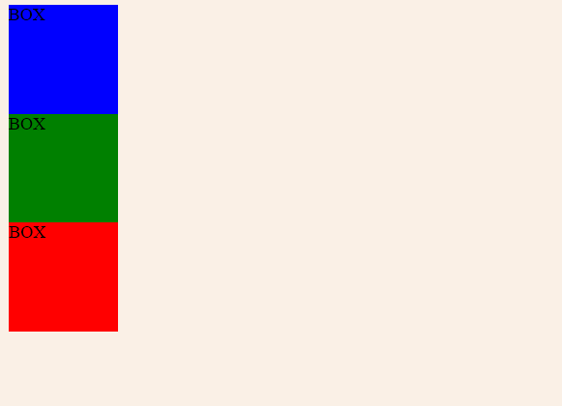

# Create a student registration system page using HTML tags and apply box model using external CSS.

***Index.html***

<!DOCTYPE html>

<head>

<meta name="viewport" content="width=device-width, initial- scale=1.0">

<title>Student Registration Form</title>

<link rel="stylesheet" href="style.css">

</head>

<body>

<form class="signup-form" action="/register" method="post">

<div class="form-header">

<h1>Registration</h1>

</div>

<div class="form-body">

<div class="horizontal-group">

<div class="form-group left">

<label for="firstname" class="label-title">First name *</label>

<input type="text" id="firstname" class="form-input" placeholder="enter your first name" required="required" />

</div>

<div class="form-group right">

<label for="lastname" class="label-title">Last name</label>

<input type="text" id="lastname" class="form-input" placeholder="enter your last name" />

</div>

</div>

<div class="form-group">

<label for="email" class="label-title">Email*</label>

<input type="email" id="email" class="form-input" placeholder="enter your email" required="required">

</div>

<div class="horizontal-group">

<div class="form-group left">

<label for="password" class="label-title">Password *</label>

<input type="password" id="password" class="form-input" placeholder="enter your password" required="required">

</div>

<div class="form-group right">

<label for="confirm-password" class="label-title">Confirm Password *</label>

<input type="password" class="form-input" id="confirm- password" placeholder="enter your password again" required="required">

</div>

<div class="horizontal-group">

<div class="form-group left">

<label class="label-title">Gender:</label>

<div class="input-group">

<label for="male">

<input type="radio" name="gender" value="male" id="male"> Male</label>

<label for="female">

<input type="radio" name="gender" value="female" id="female"> Female</label>

</div>

</div>

<div class="form-group right">

<label class="label-title">Hobbies</label>

<div>

<label>

<input type="checkbox" value="Web">Music</label>

<label>

<input type="checkbox" value="iOS">Sports</label>

<label>

<input type="checkbox" value="Andriod">Travel</label>

<label>

<input type="checkbox" value="Game">Movies</label>

</div>

</div>

</div>

<div class="horizontal-group">

<div class="form-group left" >

<label class="label-title">Source of Income</label>

<select class="form-input" id="level" >

<option value="B">Employed</option>

<option value="I">Self-employed</option>

<option value="A">Unemployed</option>

</select>

</div>

<div class="form-group right">

<label for="experience" class="label-title">Income</label>

<input type="range" min="20" max="100" step="5" value="0" id="experience" class="form-input" onChange="change();" style="height:28px;width:78%;padding:0;">

<span id="range-label">20K</span>

</div>

</div>

<div class="horizontal-group">

<div class="form-group left" >

<label for="choose-file" class="label-title">Upload Profile Picture</label>

<input type="file" id="choose-file" size="80">

</div>

<div class="form-group right">

<label for="experience" class="label-title">Age</label>

<input type="number" min="18" max="80" value="18" class="form- input">

</div>

</div>

<div class="form-group">

<label for="choose-file" class="label-title">Bio</label>

<textarea class="form-input" rows="4" cols="50" style="height:auto"></textarea>

</div>

</div>

<div class="form-footer">

<!-- form footer -->

<div class="form-footer">

<span>* required</span>

<button type="submit" class="btn">Create</button>

</div>

</div>

</form>

<script>

var rangeLabel = document.getElementById("range-label"); var experience = document.getElementById("experience"); function change() {

rangeLabel.innerText = experience.value + "K";

}

</script>

</body>

</html>

***Style.css***

@importurl('httpss://fonts.googleapis.com/css?family=Roboto'); body {

background:linear-gradient(to right, #78a7ba 0%, #385D6C 50%,

#78a7ba 99%);

}

.signup-form {

font-family: "Roboto", sans-serif; width:650px;

margin:30px auto;

background:linear-gradient(to right, #ffffff 0%, #fafafa 50%,

#ffffff 99%);

border-radius: 10px;

}

.form-header {

background-color: #EFF0F1; border-top-left-radius: 10px; border-top-right-radius: 10px;

}

.form-header h1 { font-size: 30px; text-align:center; color:#666; padding:20px 0;

border-bottom:1px solid #cccccc;

}

.form-body { padding:10px 40px;

color:#666;

}

.form-group{

margin-bottom:20px;

}

.form-body .label-title { color:#1BBA93;

font-size: 17px; font-weight: bold;

}

.form-body .form-input { font-size: 17px;

box-sizing: border-box; width: 100%;

height: 34px; padding-left: 10px; padding-right: 10px;

color: #333333; text-align: left;

border: 1px solid #d6d6d6; border-radius: 4px;

background: white; outline: none;

}

.horizontal-group .left{ float:left;

width:49%;

}

.horizontal-group .right{ float:right;

width:49%;

}

input[type="file"] { outline: none;

cursor:pointer; font-size: 17px;

}

#range-label { width:15%; padding:5px;

background-color: #1BBA93; color:white;

border-radius: 5px; font-size: 17px; position: relative;

top:-8px;

}

::-webkit-input-placeholder { color:#d9d9d9;

}

.form-footer { clear:both;

}

.signup-form .form-footer { background-color: #EFF0F1; border-bottom-left-radius: 10px; border-bottom-right-radius: 10px; padding:10px 40px;

text-align: right;

border-top: 1px solid #cccccc;

}

.form-footer span { float:left;

margin-top: 10px; color:#999;

font-style: italic; font-weight: thin;

}

.btn {

display:inline-block; padding:10px 20px; background-color: #1BBA93;

font-size:17px; border:none;

border-radius:5px; color:#bcf5e7; cursor:pointer;

}

.btn:hover {

background-color: #169c7b;

color:white;

}

***Output:-***

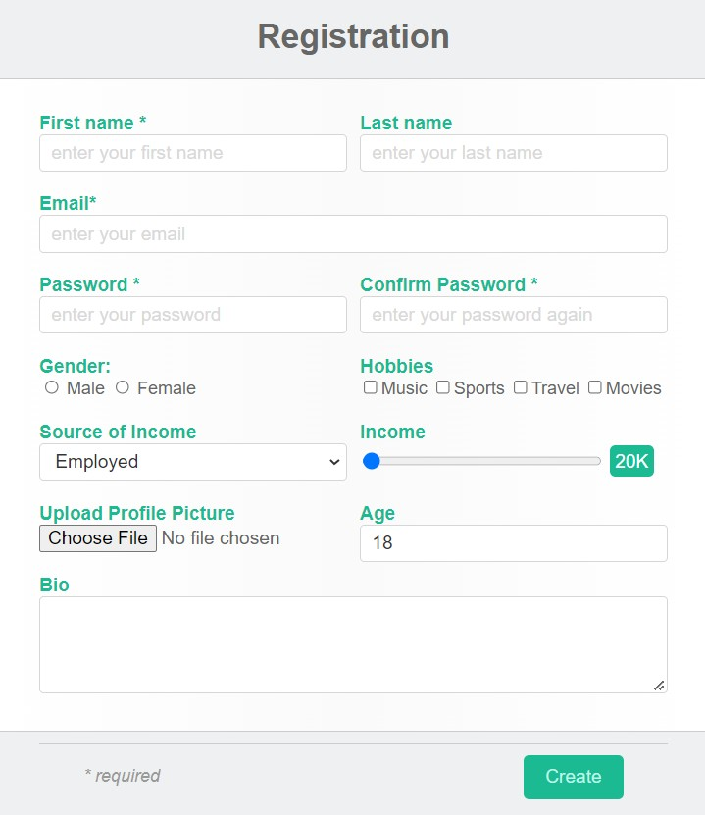

# 7 A. Write a JavaScript program to test the first character of a string is uppercase or not.

function upper_case(str)

{

regexp = /^[A-Z]/;

if (regexp.test(str))

{

console.log("String's first character is uppercase");

}

else

{

console.log("String's first character is not uppercase");

}

}

upper_case('Abcd'); upper_case('abcd');

# B.Write a JavaScript code to take color from user and apply that color to Div tag.

<html>

<head>

<style>

#Myelement { width: 500px; height: 100px;

}

</style>

</head>

<body>

<div id="Myelement" onclick="changeColor()">

</div>

<input name="MyColorPicker" type="color" id="MyColorPicker" />

</body>

</html>

<script>

function changeColor() { document.getElementById(

"Myelement").style.backgroundColor = document.getElementById(

"MyColorPicker").value;

}

</script>

***Output:-***

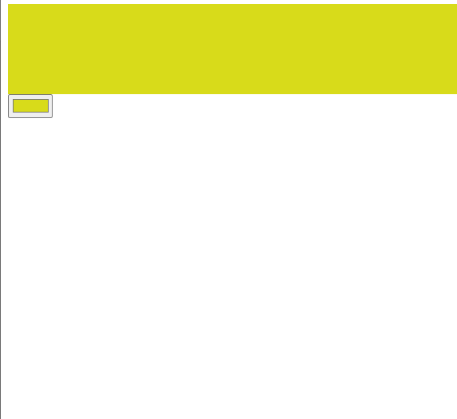

# Write JavaScript to validate the following fields of the Registration page. 1. First Name (Name should be min 4 characters and max 8 characters) 2. Password & Confirm Password (Password should not be less than 8 characters length). 3. Email id (should not contain any invalid mail) 4. Mobile Number (Phone number should be 8 digits only) 5. Last Name and Address (should not be Empty).

***Index.html***

<html>

<head>

<style>

.content

{

padding: 50px; margin-left: 25%;

}

input

{

padding: 10px;

}

</style>

</head>

<body>

<h1 class="abhi">Login</h1>

<div class="content">

<label for="name">Full Name:</label>

<input type="text" onblur="nameCheck()" value="" id="fname"><br>

<label for="name">Password:</label>

<input type="password" onblur="passCheck()" value="" id="pass"><br>

<label for="name"> Confirm Password:</label>

<input type="password" onblur="conPassCheck()" value="" id="cpass"><br>

<label for="name">E-mail</label>

<input type="email" onblur="eCheck()" value="" id="mail"><br>

<label for="mob">Mobile:</label>

<input type="text" onblur="mCheck()" value="" id="phone"><br>

<label for="lname">Last Name:</label>

<input type="text" onblur="lnCheck()" value="" id="lname"><br>

<label for="Address">Address:</label>

<input type="text" onblur="addCheck()" value="" id="add">

</div>

</body>

<script src="app.js"></script>

</html>

***App.js***

function nameCheck() {

var x = document.getElementById("fname");

if (!(x.value.length>= 4 &&x.value.length<= 8)) {

alert("Name should be at least 4 char and max 8 char long"); x.value="";

}

}

function passCheck() {

var paswd = /^(?=.*[0-9])(?=.*[!@#$%^&*])[a-zA-Z0- 9!@#$%^&*]{8,}$/;

var x = document.getElementById("pass"); if (!(x.value.match(paswd))) {

alert("Enter Valid password");

}

}

function conPassCheck() {

var x = document.getElementById("pass"); var y = document.getElementById("cpass"); if (!(x.value==y.value)) {

alert("Confirm password should be same as the password");

}

}

function eCheck() {

var email = document.getElementById("pass"); if(email.value=="")

{

alert('Please fill this field');

}

var filter = /^([a-zA-Z0-9_\.\-])+\@(([a-zA-Z0-9\-])+\.)+([a- zA-Z0-9]{2,4})+$/;

if (!filter.test(email.value)) {

alert("Please provide a valid email address");

}

}

function mCheck() {

var x = document.getElementById("phone"); if (!(x.value.length == 8)) {

alert("Phone Number should be 8 char long");

}

}

function lnCheck() {

var x = document.getElementById("lname"); if (x.value == "") {

alert("Please fill this field");

}

}

function addCheck() {

var x = document.getElementById("add"); if (x.value == "") {

alert("Please fill this field");

}

}

***Output:*-**

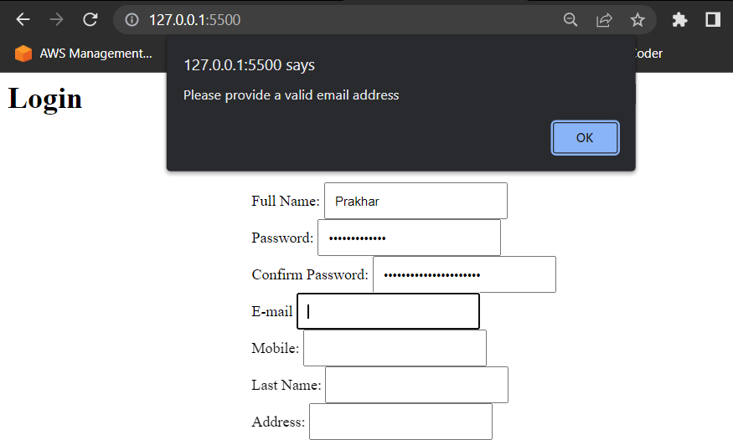

# Create a HTML form and write JavaScript to generate the invoice with one click of GENERATE INVOICE button. Take any 5 product with rate and quantity and display total for every product. Calculate Grand Total by

**including 18% GST.**

<!DOCTYPE html>

<head>

<meta name="viewport" content="width=device-width, initial- scale=1.0">

<title>Document</title>

<style> table{

border: 2px solid black; border-collapse: collapse;

}

input{

margin: 5px;

}

th,td{

}

border-bottom: 1px solid black;

</style>

</head>

<body>

<table>

<tr>

<th>particulars</th>

<th>rate</th>

<th>quantity</th>

<th>total</th>

</tr><tr>

<td>Product 1</td>

<td><input type="text" id="rate1"></td>

<td><input type="text" id="quantity1"></td>

<td><input type="text" id="total1"></td>

</tr><tr>

<td>Product 2</td>

<td><input type="text" id="rate2"></td>

<td><input type="text" id="quantity2"></td>

<td><input type="text" id="total2"></td>

</tr><tr>

<td>Product 3</td>

<td><input type="text" id="rate3"></td>

<td><input type="text" id="quantity3"></td>

<td><input type="text" id="total3"></td>

</tr><tr>

<td>Product 4</td>

<td><input type="text" id="rate4"></td>

<td><input type="text" id="quantity4"></td>

<td><input type="text" id="total4"></td>

</tr><tr>

<td>Product 5</td>

<td><input type="text" id="rate5"></td>

<td><input type="text" id="quantity5"></td>

<td><input type="text" id="total5"></td>

</tr><tr>

<td colspan="4" style="text-align:center"> Tax : <input type="text" id="tax"> Based on a 18% GST</td>

</tr><tr>

<td colspan="4" style="text-align:center">Grandtotal : <input type="text" id="grandtotal"> Vat included</td>

</tr>

</table>

<script>

let total1 = document.getElementById('total1'); let total2 = document.getElementById('total2'); let total3 = document.getElementById('total3'); let total4 = document.getElementById('total4'); let total5 = document.getElementById('total5'); let p1total = 0;

let p2total = 0; let p3total = 0; let p4total = 0; let p5total = 0;

total1.addEventListener('click', function fun() {

let rate1 =parseInt(document.getElementById('rate1').value); let quantity1 =

parseInt(document.getElementById('quantity1').value); p1total = rate1 * quantity1;

total1.value = p1total;

});

total2.addEventListener('click', function fun() { let rate2 =

parseInt(document.getElementById('rate2').value); let quantity2 =

parseInt(document.getElementById('quantity2').value); p2total = rate2 * quantity2;

total2.value = p2total;

});

total3.addEventListener('click', function fun() { let rate3 =

parseInt(document.getElementById('rate3').value); let quantity3 =

parseInt(document.getElementById('quantity3').value); p3total = rate3 * quantity3;

total3.value = p3total;

});

total4.addEventListener('click', function fun() { let rate4 =

parseInt(document.getElementById('rate4').value); let quantity4 =

parseInt(document.getElementById('quantity4').value); p4total = rate4 * quantity4;

total4.value = p4total;

});

total5.addEventListener('click', function fun() { let rate5 =

parseInt(document.getElementById('rate5').value); let quantity5 =

parseInt(document.getElementById('quantity5').value); p5total = rate5 * quantity5;

total5.value = p5total;

});

let tax = 0;

let taxinpt = document.getElementById('tax'); taxinpt.addEventListener('click', ()=>{

tax = (p1total+p2total+p3total+p4total+p5total)*0.18; taxinpt.value = tax;

});

let gt = document.getElementById('grandtotal'); gt.addEventListener('click', ()=>{

gt.value = p1total+p2total+p3total+p4total+p5total+tax;

})

</script>

</body>

</html>

***Output:-***

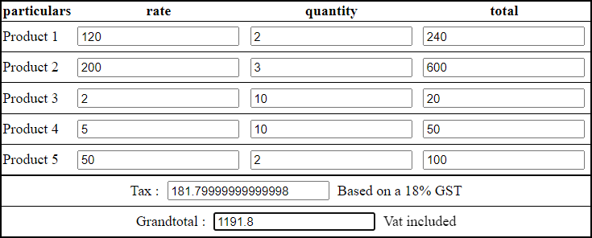

# 10 A .Write a JQuery code to give animation to div on click of button.

<!DOCTYPE html>

<html>

<head>

<script src="https://ajax.googleapis.com/ajax/libs/jquery/3.6.0/jquer y.min.js"></script>

<script>

$(document).ready(function(){

$("button").click(function(){

$("div").animate({ left: '250px',

opacity: '0.5', height: '150px', width: '150px'

});

});

});

</script>

</head>

<body>

<button>Start Animation</button>

*<div* style="background:#98bf21;height:100px;width:100px;position*: absolute;"></div>*

</body>

</html>

***Output:-***

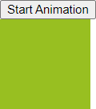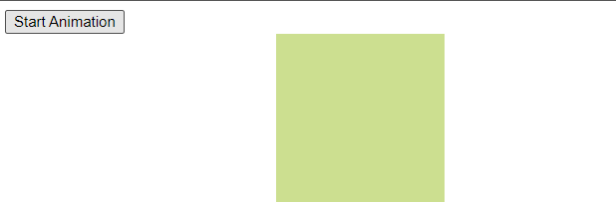

# B. Write a JQuery code to add dynamic element on page on click of button.

<!DOCTYPE html>

<html lang="en">

<head>

<meta charset="utf-8">

<title>jQuery Bind Click Event to Dynamically added Elements</title>

<script src="https://code.jquery.com/jquery- 3.5.1.min.js"></script>

<script>

$(document).ready(function () {

$("button").click(function () {

$("ol").append("<li>Milk <a href='javascript:void(0);' class='remove'>&times;</a></li>");

});

$(document).on("click", "a.remove", function () {

$(this).parent().remove();

});

});

</script>

</head>

<body>

<button>Add Milk</button>

<p>Click the above button to add milk. <p>

<ol>

<li>Milk</li><li>Milk</li><li>Milk</li>

</ol>

</body>

</html>

***Output:-***

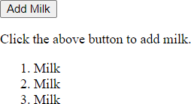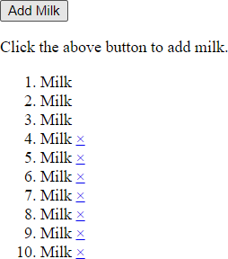

# Write a jQuery program to demonstrate the use of mouse event, keyboard eventand form event.

<!DOCTYPE html>

<head>

<meta name="viewport" content="width=device-width, initial- scale=1.0">

<title>Program 11</title>

<script src="https://ajax.googleapis.com/ajax/libs/jquery/3.6.0/jquery. min.js"></script>

<script>

let i = 0;

$(document).ready(function () {

//Mouse Event

$("p").click(function () {

$(this).hide();

})

$("#p1").hover(function () { alert("You entered p1!");

},

function () {

alert("Bye! You now leave p1!");

})

//Keyboard event

$("input").keypress(function () {

$("span").text(i += 1);

});

//Form event

$("#target").blur(function () { alert("Handler for .blur() called.");

});

});

</script>

</head>

<body>

<p>Click me first</p>

<p>Click me second</p>

<p id="p1" style="display: inline; border: 2px solid red">This is text</p><br><br>

Enter your name: <input type="text">

<p>Keypresses: <span>0</span></p>

<form>

<input id="target" type="text" value="Field 1">

</form>

</body>

</html>

***Output:-***

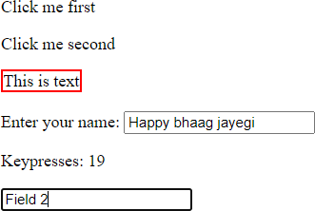

# Write a jQuery program to demonstrate the use of display effect, fade effect and slide effect.

<!DOCTYPE html>

<html>

<head>

<script src="https://ajax.googleapis.com/ajax/libs/jquery/3.6.0/jquery. min.js"></script>

<script>

$(document).ready(function () {

//Display Effect

$(".btn1").click(function () {

$("p").hide();

});

$(".btn2").click(function () {

$("p").show();

});

//Fade Effect

$("button").click(function () {

$("#div1").fadeToggle();

$("#div2").fadeToggle("slow");

$("#div3").fadeToggle(3000);

})

//Side Effect

$("#flip").click(function () {

$("#panel").slideToggle("slow");

});

});

</script>

<style>

#panel, #flip {

padding: 5px; text-align: center; width: 50%;

background-color: rgb(83, 219, 83); border: solid 1px #c3c3c3;

margin: auto;

}

#panel { padding: 50px; display: none;

}

</style>

</head>

<body>

<p>This is a paragraph.</p>

<button class="btn1">Hide</button>

<button class="btn2">Show</button>

<br><br>

<button>Click to fade in/out boxes</button><br><br>

<div id="div1" style="width:80px;height:80px;background- color:red;"></div>

<br>

<div id="div2" style="width:80px;height:80px;background- color:green;"></div>

<br>

<div id="div3" style="width:80px;height:80px;background- color:blue;"></div>

<br><br>

<div id="flip">Click to slide the panel down or up</div>

<div id="panel">Hello world!</div>

</body>

</html>

***Output:-***

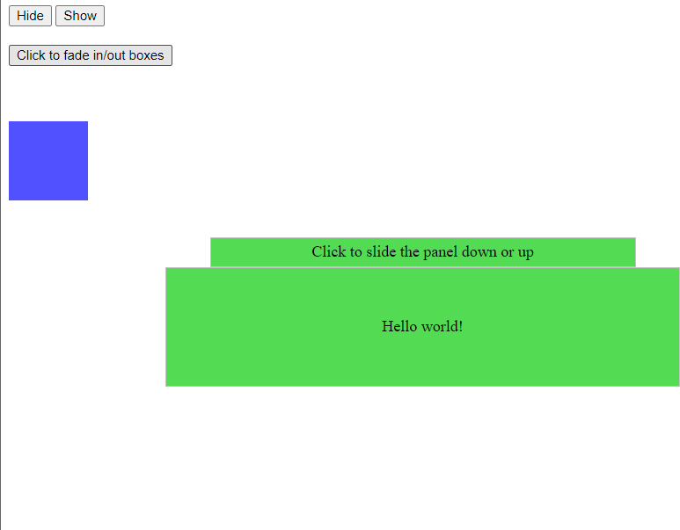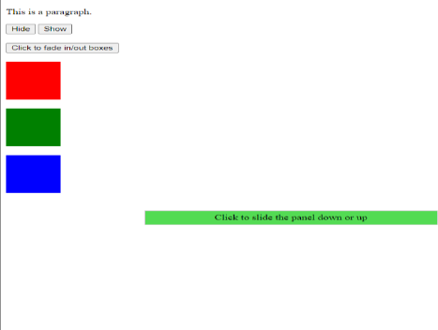

# 13.A simple calculator web application that takes two numbers and an operator (+, -, /,*and %) from an HTML page and returns the result page with the operation performed on the operands.

<!DOCTYPE html>

<html lang="en">

<head>

<meta charset="UTF-8">

<meta http-equiv="X-UA-Compatible" content="IE=edge">

<meta name="viewport" content="width=device-width, initial- scale=1.0">

<title>Document</title>

</head>

<body>

<form>

<label for="num1">Number1</label>

<input type="number" id="num1" name="num1"><br>

<label for="num2">Number2</label>

<input type="number" id="num2" name="num2"><br>

<br>

<label for="opr">Choose Operation :</label>

<select name="opr" id="opr">

<option value="add">Add</option>

<option value="sub">Subtract</option>

<option value="div">Divide</option>

<option value="mul">Multiply</option>

</select>

<br>

<input type="button" onClick="submit()" id="submit" value="Submit"><br>

<p>Result :</p>

<p id="res"></p>

</form>

<script>

but = document.getElementById('submit'); but.addEventListener("click" , function()

{

num1 = parseInt(document.getElementById("num1").value); num2 = parseInt(document.getElementById("num2").value)

opr = document.getElementById('opr');

select = opr.options[opr.selectedIndex].value; if(select == 'add')

{

cal = num1+num2; document.getElementById('res').innerHTML = cal;

}

else if(select == 'sub')

{

cal = num1-num2; document.getElementById('res').innerHTML = cal;

}

else if(select == 'div')

{

cal = num1/num2; document.getElementById('res').innerHTML = cal;

}

else if(select == 'mul')

{

cal = num1*num2; document.getElementById('res').innerHTML = cal;

}

});

</script>

</body>

</html>

***Output:-***

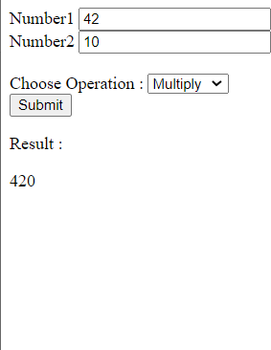

# Write PHP program for student registration. Perform insert, display, update and delete operations from database. (use any database).

## _db_connect.php

<?php

$server = "localhost";

$username = 'root';

$password = '';

$database = "student";

$conn = mysqli_connect($server, $username, $password,

$database); if(!$conn)

die("Error " . mysqli_connect_error()); else

echo 'Connection made successfully!!'

?>

***Output:-***



## welcome.php

<!DOCTYPE html>

<html lang="en">

<head>

<meta charset="UTF-8">

<meta http-equiv="X-UA-Compatible" content="IE=edge">

<meta name="viewport" content="width=device-width, initial- scale=1.0">

<title>Welcome</title>

<style> div{

display: flex;

justify-content: center; align-items: center; margin-top: 210px;

}

li{

font-size:30px;

}

</style>

</head>

<body>

<div>

<ul>

<li><a class="nav-link" href="insert.php">Insert</a></li>

<li><a class="nav-link" href="display.php">Display</a></li>

<li><a class="nav-link" href="update.php">Update</a></li>

<li><a class="nav-link" href="delete.php">Delete</a></li>

</ul>

</div>

</body>

</html>

***Output:***

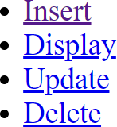

***insert.php***

<?php

if($_SERVER['REQUEST_METHOD'] == 'POST') {

$name = $_POST['name'];

$email = $_POST['email'];

$gender = $_POST['gender']; if($gender == 'male') {

$gender = 'm';

}else $gender = 'f';

require 'partials/_db_connect.php';

$sql = "INSERT INTO student(`name`, `email`, `gender`) values('$name', '$email', '$gender')";

$result = mysqli_query($conn, $sql); if($result) {

echo "<script> alert('Regitration Successful');

</script>";

}else {

echo "<script> alert('Not Registered');

</script>";

}

}

?>

<!DOCTYPE html>

<html lang="en">

<head>

<meta charset="UTF-8">

<meta http-equiv="X-UA-Compatible" content="IE=edge">

<meta name="viewport" content="width=device-width, initial- scale=1.0">

<title>Insert</title>

<style>

#container{ display: flex;

justify-content: center; align-items: center; margin-top:210px;

}

a{

font-size:25px;

}

</style>

</head>

<body>

<h2>

<a href="/anant/registration/Welcome.php">Home</a>

</h2>

<div id="container">

<form action="insert.php" method="post">

<label for="name">Name :</label>

<input type="text" name="name" id="name"><br><br>

<label for="email">Email :</label>

<input type="email" name="email" id="email">

<h3>Gender</h3>

<input type="radio" name="gender" id="male" value="male">

<label for="male">Male</label>

<input type="radio" name="gender" id="female" value="female">

<label for="female">Female</label><br><br>

<button type="submit" id="btn">Submit</button>

</form>

</div>

</body>

</html>

***Output:***

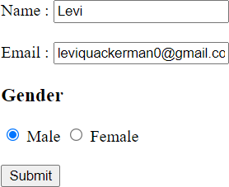

***display.php***

<?php

echo '<title>Display</title>'; echo '

<h2>

<a style="font-size:25px;" href="/anant/registration/Welcome.php">Home</a>

</h2>';

require 'partials/_db_connect.php';

$sql = 'SELECT * FROM student';

$result = mysqli_query($conn, $sql); if($result) {

$num = mysqli_num_rows($result); if($num> 0) {

echo '<table border="2" cellspacing="3" cellpadding="2">

<tr>

<th>Name</td>

<th>Email</td>

<th>Gender</td>

</tr>';

while($row = mysqli_fetch_assoc($result)) {

$gen = "Male";

if($row['gender'] == 'f') $gen = 'Female'; echo

'<tr>

<td>'.$row['name'].'</td>

<td>'.$row['email'].'</td>

<td>'.$gen.'</td>

</tr>';

}

echo '</table>';

}

}

?>

***Output:***

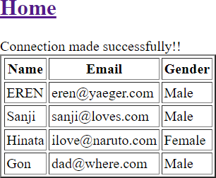

***update.php***

<?php

if($_SERVER['REQUEST_METHOD'] == 'POST') {

$name = $_POST['name'];

$email = $_POST['email'];

require 'partials/_db_connect.php';

$sql = "update student set `email` = '$email' where `name` = '$name'";

$result = mysqli_query($conn, $sql); if($result) {

echo "<script> alert('Updation Successful');

</script>";

}else {

echo "<script> alert('User Not Found');

</script>";

}

}

?>

<!DOCTYPE html>

<html lang="en">

<head>

<meta charset="UTF-8">

<meta http-equiv="X-UA-Compatible" content="IE=edge">

<meta name="viewport" content="width=device-width, initial- scale=1.0">

<title>Update</title>

<style> a{

font-size:25px;

}

</style>

</head>

<body>

<h2>

<a href="/anant/registration/Welcome.php">Home</a>

</h2>

<form action="update.php" method="post">

<label for="name">Name:</label>

<input type="text" placeholder="Enter Name" name="name"><br><br>

<label for="email">Enter your New Email:</label>

<input type="email" placeholder="Enter new Email" name="email">

<button type="submit">Update</button>

</form>

</body>

</html>

***Output:***

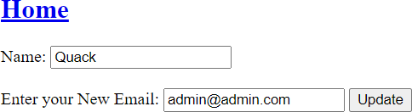

***delete.php***

<?php

if($_SERVER['REQUEST_METHOD'] == 'POST') {

$name = $_POST['name'];

require 'partials/_db_connect.php';

$sql = "delete from `student` where `name`='$name'";

$result = mysqli_query($conn, $sql); if($result) {

echo "<script> alert('Deletion Successful');

</script>";

}else {

echo "<script> alert('User Not Found');

</script>";

}

}

?>

<!DOCTYPE html>

<html lang="en">

<head>

<meta charset="UTF-8">

<meta http-equiv="X-UA-Compatible" content="IE=edge">

<meta name="viewport" content="width=device-width, initial- scale=1.0">

<title>Delete</title>

<style> a{

font-size:25px;

}

</style>

</head>

<body>

<h2>

<a href="/anant/registration/Welcome.php">Home</a>

</h2>

<form action="delete.php" method="post">

<label for="name">Name:</label>

<input type="text" placeholder="Enter Name" name="name">

<button type="submit">Delete</button>

</form>

</body>

</html>

***Output:***

### Before deletion:- Deletion command:-

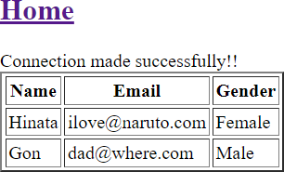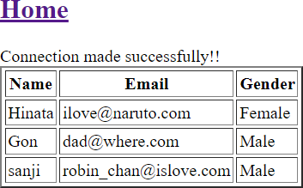

***After deletion:-***

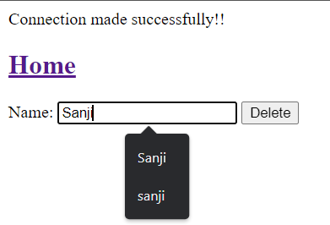

### Write a PHP program to store current date-time in a COOKIE and display the ‘Last visited on’ date-time on the web page upon reopening of the same page.

<?php

// time for 60 days in future

$cookie_value = time() + 60*60*60*24; setcookie('lastvisit' , date("G:i , m/d/y") , $cookie_value , )

?>

<?php

if(isset($_COOKIE['lastvisit']))

{

echo "Your last visit time and date are : " .

$_COOKIE['lastvisit'] . "<br>"; setcookie('lastvisit',"",time()-3600);

}

else{

echo "This is your first visit <br>";

}

?>

***Output:-***

